GREEN MARKETING AND SUSTAINABLE CONSUMER BEHAVIOUR IN THE INDIAN FMCG INDUSTRY: AN EMPIRICAL STUDY OF HINDUSTAN UNILEVER

Dr. V Jothi Francina¹, Dr. M. Kumar², Dr. R. Nithya^{3,} Dr. S. Ranganayagi ⁴ , Dharshini P ⁵, Thulasi S⁶

¹Assistant Professor, Department of Management Studies, Sona College of Technolog, Salem,Tamilnadu, jothifrancina@sonabusinessschool.com
²Professor, Department of Management Studies (MBA), RP Sarathy Institute of Technology, alem. mkumarphd05@gmail.com
³Associate Professor,AVS Engineering College, Salem, nithiroyappan@gmail.com
^{4.}Dr. S.Ranganayagi,-Professor, RP Sarathy Institute of Technology Salem, ranganayagi720@gmail.com
⁵⁻⁶ PG Student, Department of Management Studies, Sona College of Technology, Salem, Tamil Nadu, India.

ABSTRACT
Growing environmental concerns and increasing demand for sustainable products have made green marketing an important strategic approach for influencing consumer behaviour in the fast-moving consumer goods (FMCG) sector. This study investigates the impact of green marketing initiatives implemented by Hindustan Unilever Limited (HUL) on consumer awareness and eco-friendly buying behaviour in India. A quantitative research design was employed using secondary data from 1,200 consumers. Statistical techniques, including correlation and multiple regression analyses, were applied to examine the relationships among green marketing initiatives, consumer awareness, and sustainable purchasing behaviour.
The findings indicate that HUL's green marketing initiatives significantly influence consumers' eco-friendly purchase decisions, although their effect on enhancing environmental awareness is relatively limited. The results further demonstrate that emotional and cultural dimensions, particularly eco-pride and cultural eco-alignment, exert a stronger influence on sustainable purchasing behaviour than knowledge-based factors. In addition, social media was identified as the most effective communication channel for promoting green products and encouraging environmentally responsible consumer choices.
The study concludes that while HUL's green marketing strategies effectively encourage sustainable consumption, greater emphasis should be placed on educational and awareness-building initiatives to strengthen consumers' environmental knowledge. The findings contribute to the growing body of literature on green marketing and offer practical implications for marketers, policymakers, and businesses seeking to promote sustainable consumer behaviour in emerging economies such as India.

KEYWORDS: Green Marketing; Consumer Awareness; Eco-friendly Buying Behaviour; Hindustan Unilever Limited (HUL); Sustainable Consumption

INTRODUCTION
The twenty-first century has witnessed unprecedented industrialization, urbanization, and consumerism, resulting in significant environmental challenges such as climate change, resource depletion, biodiversity loss, and escalating plastic pollution. As concerns over environmental sustainability continue to grow, governments, businesses, and consumers are increasingly recognizing the need to adopt sustainable production and consumption practices. Consequently, sustainability has become a fundamental principle guiding business strategies and consumer decision-making.
Green marketing, also referred to as environmental or sustainable marketing, has emerged as an important strategic approach that enables organizations to address environmental challenges while creating long-term competitive advantage. The American Marketing Association defines green marketing as the marketing of products that are presumed to be environmentally safe. However, the concept extends beyond environmentally friendly products to encompass the entire product life cycle, including sustainable sourcing of raw materials, environmentally responsible manufacturing, eco-friendly packaging, distribution, marketing communications, and end-of-life disposal. As a result, green marketing represents a comprehensive business philosophy that integrates environmental responsibility with organizational performance.
In recent years, businesses have increasingly adopted green marketing practices to strengthen corporate sustainability, enhance brand reputation, and differentiate themselves in highly competitive markets. Environmentally responsible initiatives have become important drivers of customer loyalty, brand equity, and long-term organizational success. In India, the growing environmental consciousness among consumers, rapid expansion of the middle-income population, and supportive government initiatives promoting sustainable development have accelerated the adoption of green marketing across the fast-moving consumer goods (FMCG) sector.

Hindustan Unilever Limited (HUL), a subsidiary of Unilever, is one of India's largest FMCG companies and has been at the forefront of implementing sustainability-driven marketing strategies. Through a portfolio of more than 50 brands spanning personal care, home care, food, beverages, and water purification products, HUL reaches nearly 90% of Indian households. Since launching its Sustainable Living Plan in 2010, the company has integrated sustainability into its core business strategy through initiatives focused on reducing environmental impact, promoting responsible consumption, improving recyclable packaging, and encouraging sustainable consumer behaviour.
This article investigates the impact of HUL's green marketing initiatives on consumer awareness and eco-friendly buying behaviour within the Indian FMCG sector. Using quantitative data obtained from 1,200 consumers and employing statistical techniques including correlation and regression analysis, the study examines the relationships between green marketing initiatives, consumer awareness, and sustainable purchasing behaviour. The findings contribute to the growing literature on green marketing by providing empirical evidence from an emerging economy and offer practical implications for marketers, policymakers, and organizations seeking to promote sustainable consumption.

Overview and Market Size
The Fast-Moving Consumer Goods (FMCG) sector is among the largest and most economically significant industries in India. The valuation of the Indian FMCG market reached approximately USD 167 billion in 2023-24 which positioned it as the fourth largest FMCG market worldwide after the United States, China, and Japan. The industry analysts expect the market to grow from its current value to USD 220 billion by 2025 and to exceed USD 615 billion by 2035 because of multiple factors which include increasing incomes, urban development, demographic growth, and the expansion of online shopping platforms. The FMCG sector includes multiple product categories which range from food and beverages to personal care products and household and fabric care and healthcare and over-the-counter medicines and consumer electronics. The major FMCG companies in India include Hindustan Unilever and ITC Limited and Nestlé India and Procter & Gamble and Dabur and Godrej Consumer Products and Marico and Britannia. HUL maintains the highest market share in the industry which confirms its status as the leading company in the Indian FMCG market.

Table 1: Overview of the Indian FMCG Market
Parameter | Details
Market Size (2023–24) | USD 167 Billion
Projected Size (2035) | USD 615 Billion
CAGR (2023–2035) | 12%
Top Market Segments | Food & Beverages (19%), Healthcare (31%),  Household Care (50%)
Urban Market Share | 55%
Rural Market Share | 45%
Number of FMCG Companies (India) | Over 700 registered
Employment (Direct & Indirect) | Over 30 million people
E-commerce FMCG Share | 11% (growing at 30% )
Key Growth Drivers | Rising disposable incomes, urbanisation, digital penetration, and premiumisation

Growth Trends and Market Dynamics
The Indian FMCG sector has shown exceptional strength because it has successfully adjusted to major economic challenges which include the COVID-19 pandemic and rising inflation and supply chain problems. The rural segment which represents about 45 of total FMCG revenues has emerged as a crucial growth engine because of government-sponsored rural development programs and enhanced digital and physical infrastructure. The structural transformations that occurred after the pandemic have created new patterns of FMCG consumption. Consumers have shown strong preference for health hygiene and wellness products which supports the green marketing movement. The rise of digital commerce through quick commerce platforms like Blinkit Swiggy Instamart and Zepto has created a new distribution system that helps FMCG businesses deliver products to urban customers with faster and more accurate methods.

The trend of premiumisation shows its most significant impact in urban markets because customers there show their readiness to pay extra for products which deliver better quality and natural components and environmentally friendly packaging and products which have sustainable sourcing practices. The emerging trend creates an ideal situation for green marketing programs because it brings together business interests and environmental protection requirements.

Sustainability Initiatives in the Indian FMCG Sector
The Indian FMCG market has recognized sustainability as the most important competitive element of its business operations. The Extended Producer Responsibility (EPR) framework established by India's Plastic Waste Management Rules and the Business Responsibility and Sustainability Reporting (BRSR) requirement for top-listed companies introduced by SEBI have created regulatory pressures that force FMCG companies to integrate sustainability into their business operations and marketing activities.
Major Indian FMCG companies have responded to this situation by setting ambitious sustainability targets for their operations. The product environmental footprint at HUL will be reduced by 50% while the company demonstrates better social benefits. ITC Limited has maintained its status as carbon positive and water positive and solid waste recycling positive for more than ten years. By the year 2025, Dabur will use only packaging materials that can be fully recycled or made from recycled content. Nestlé India has committed to reaching net-zero emissions by 2050 while removing all single-use plastic products from its business operations.
The Indian FMCG industry adopts green marketing because of changing consumer behavior according to the increasing market presence of millennials. The environmental awareness of millennials and Generation Z consumers, who make up more than half of India's total population, leads them to consider sustainability when making their purchasing decisions. The upcoming decade will bring consumption pattern changes which create both chances and requirements for green FMCG marketing.

Statement of the Problem
Growing environmental concerns, including climate change, resource depletion, and pollution, have increased the importance of sustainable production and consumption practices. Green marketing has emerged as a strategic approach that enables organizations to promote environmentally responsible products while strengthening their competitive advantage. However, previous studies have identified a persistent attitude–behaviour gap, where consumers express positive environmental attitudes but often fail to translate them into actual green purchasing decisions. This challenge is particularly evident in developing economies such as India, where factors such as price sensitivity, brand loyalty, and skepticism toward environmental claims influence consumer behaviour. Although Hindustan Unilever Limited has implemented extensive green marketing initiatives, limited empirical evidence exists on how these initiatives influence consumer awareness and eco-friendly buying behaviour in the Indian FMCG sector. Therefore, this article investigates the relationship between HUL's green marketing practices, consumer awareness, and sustainable purchasing behaviour, providing insights that can support businesses, marketers, and policymakers in promoting sustainable consumption.

Concepts of Green Marketing
Green marketing which people also call sustainable marketing and eco-marketing and environmental marketing creates a challenge to establish one standard definition because it combines multiple disciplines and both academic research and business practices continue to develop. A selection of prominent definitions illustrates the breadth and evolution of the concept:
The most comprehensive and widely accepted definition of green marketing is given by Fabio Dangelico and Pierpaolo Vocalelli (2017), who describe it as marketing activities that generate market exchanges which fulfill customer needs while creating environmental value and stakeholder benefits. This definition is considered the best because it not only focuses on environmental protection but also integrates customer satisfaction and stakeholder value, making it more holistic, modern and aligned with sustainable business practices.

Table 2: Evolution of Green Marketing – Key Milestones
Phase | Period | Key Characteristics | Dominant Concerns
First Wave (Ecological) | 1960s–1970s | Early environmental consciousness; focus on pollution control; reactive compliance with regulations; Rachel Carson's 'Silent Spring' (1962) catalyses environmental awareness | Pollution, pesticide use, industrial waste
Second Wave (Environmental) | 1980s | Proactive green product development; emergence of eco-labels; early corporate sustainability programmes; Brundtland Report (1987) defines sustainable development | Acid rain, ozone depletion, deforestation
Third Wave (Sustainable) | 1990s–2000s | Mainstreaming of green marketing; proliferation of eco-certifications; ISO 14001 environmental management standards; emergence of the Triple Bottom Line framework; rise of CSR | Climate change, greenhouse gas emissions, biodiversity loss
Fourth Wave (Digital & Transparent) | 2010s–Present | Social media amplification of green messaging; consumer scrutiny of greenwashing; blockchain for supply chain transparency; purpose-driven marketing; Net Zero commitments; integration of SDGs | Plastic pollution, circular economy, climate emergency, net zero

REVIEW OF LITERATURE
Sharma, A. P. (2021) explored purchasing behaviour of consumer towards green products. It is analysed personal factors affecting green purchase; green purchase; and green marketing mix. Study analysed various concern for Eco environment, eco-labelling and perceived usefulness have been identified as major influencers of green consumer behaviour. Further, found that Lack of environmental knowledge, price, perceived associated risks, organizational image, trust, and willingness to pay has been identified as barriers, creating a gap between attitude and actual purchase behaviour of consumers towards green products.
Tsai, P. H., et.al (2020) evaluated brand image effects on consumers’ purchase in green marketing. Analysed evolution indicators and sub-indicators influence on network relationship in green marketing. Study found that improve the tangible effects of their green marketing strategies by stimulating consumers’ purchase intentions of the environmental consumers in green marketing.
Chung, K. C. (2020) analysed sustainable consumption behaviour of customers affects the sustainable development of the society. Study reveals the benefits of green hotel management in protecting the earth and establish a green marketing – oriented model through stress cognitive theory. It is found that stakeholders and executive corporate social responsibility hotels could indirectly increase consumer loyalty to the image of the hotel through green marketing in hotel industry.
Jaiswal and Kant (2018) examined Indian consumers who make environmentally friendly purchases and discovered that environmental knowledge together with perceived consumer effectiveness and environmental concern all function as cognitive factors which drive people to purchase green products. The research demonstrated that consumer attitude towards environmentally friendly products functions as a key link that connects product awareness with actual purchasing behavior. Because HUL uses green marketing to create initial consumer awareness their marketing strategy will eventually lead to sustainable product purchases by customers.
Kumar et al. (2021) studied Indian consumer habits for sustainable product purchases and found that Indian shoppers show greater product understanding while they hold favorable views of eco-friendly items. The research found that three factors which included subjective norms and perceived behavioral control together with environmental awareness helped to increase green purchasing behavior among customers. The research demonstrates that HUL's eco-friendly product marketing and environmental sustainability communication will impact customers through both informational content and their social connections and their trustworthiness.
Ogiemwonyi et al. (2023) studied how environmental factors impact green purchasing behavior and discovered that consumers' environmental concerns together with their knowledge and attitudes drive their purchase of eco-friendly products. The research demonstrates that green purchasing behavior is determined by more than marketing claims since consumers' environmental responsibility assessment plays a vital role in their decision-making process. HUL needs to establish credibility for its initiatives because customers will develop lasting buying patterns based on their perception of HUL's efforts.
Pancić et al. (2023) studied green marketing and repurchase intention and found that green advertising, green brand loyalty, green brand equity, and green innovativeness positively influence repeat purchase intention. The research also showed that green awareness increases the strength of these relationships. The discovery supports your subject because it shows that HUL's green marketing improves first-time customer awareness and ongoing eco-friendly purchasing when consumers comprehend the brand's environmental benefits.
Prakash et al. (2024) examined zero-waste buying behaviour in cosmetics and found that eco-friendly packaging, pro-environmental beliefs, and social-media-related influence significantly affect purchase intention. The study shows that packaging is not just functional; it also acts as a communication tool for sustainability. This is highly relevant to HUL because many of its products are fast-moving personal care and home care items where packaging innovation and green communication can strongly shape consumer awareness.
Liu et al. (2024) found that green consumption awareness and carbon-emission disclosure can influence consumer shopping choices and help convert environmental concern into actual behaviour. The study indicates that when firms provide clearer sustainability information, consumers respond more positively. This supports the relevance of HUL’s public sustainability disclosures, eco-labeling, and responsible packaging communication in influencing environmentally conscious purchase decisions.

Hindustan Unilever’s 2024–25 Business Responsibility and Sustainability Report states that HUL’s sustainability strategy focuses on climate, nature, plastics, and livelihoods, and that the company aims to provide products that meet consumer needs while minimizing environmental impact. HUL also states that it promotes consumer behaviour change through waste-management partnerships and packaging innovation. This is important because it shows that HUL’s green marketing is not only promotional, but tied to formal ESG goals and measurable sustainability commitments.

Research Design
This study adopted a descriptive and analytical research design within a quantitative research framework. The descriptive approach was used to examine the demographic and behavioural characteristics of consumers, while the analytical approach assessed the relationships between green marketing initiatives, consumer awareness, and eco-friendly buying behaviour. A positivist research paradigm was employed, enabling the use of statistical techniques to test the proposed hypotheses and generate objective, reliable, and generalizable findings.

Hypotheses
Based on the research objectives and the theoretical framework, the following hypotheses were formulated for empirical testing:
Hypothesis 1: H₀₁: Green marketing initiatives undertaken by Hindustan Unilever Limited have no significant effect on consumer awareness.
H₁₁: Green marketing initiatives undertaken by Hindustan Unilever Limited have a significant effect on consumer awareness.
Hypothesis 2: H₀₂: Social influence has no significant relationship with consumer awareness of eco-friendly products.
H₁₂: Social influence has a significant relationship with consumer awareness of eco-friendly products.
Hypothesis 3: H₀₃: Consumer awareness has no significant effect on eco-friendly buying behaviour.
H₁₃: Consumer awareness has a significant positive effect on eco-friendly buying behaviour.
Hypothesis 4: H₀₄: Green marketing initiatives undertaken by Hindustan Unilever Limited have no significant effect on consumers' eco-friendly purchase decisions.
H₁₄: Green marketing initiatives undertaken by Hindustan Unilever Limited have a significant effect on consumers' eco-friendly purchase decisions.

Data Sources
The study primarily relied on secondary data obtained from Hindustan Unilever Limited's annual and sustainability reports, peer-reviewed journal articles, industry reports, and publications from organizations such as Nielsen, KPMG, Deloitte, the Confederation of Indian Industry (CII), and regulatory agencies including SEBI and the Ministry of Environment, Forest and Climate Change.

Sampling Design
The target population comprised Indian FMCG consumers who were familiar with HUL products and marketing initiatives. The study considered a sample of 1,200
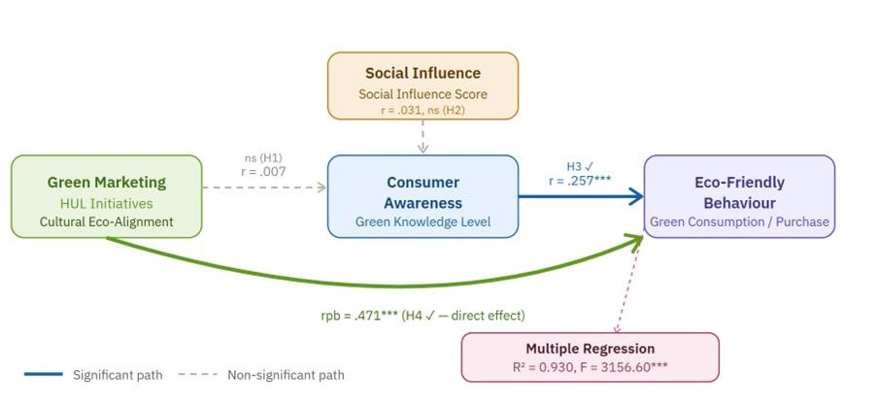
Fig. No: 1
respondents selected through convenience sampling, enabling broad consumer representation while acknowledging the limitations of non-probability sampling.
Research Instrument
Data were collected using a structured questionnaire consisting of demographic information, Likert-scale measures of green marketing constructs, and consumer buying behaviour indicators. The questionnaire was pilot-tested with 50 respondents, and all constructs demonstrated acceptable reliability, with Cronbach's alpha values exceeding 0.70.

DATA ANALYSIS & DISCUSSION

Hypothesis 1 – Green Marketing Initiatives and Consumer Awareness

Table 3: Hypothesis 1 Test Results
Test Parameter | Result
Variables Tested | Cultural Eco-Alignment vs. Green Knowledge Level
Pearson Correlation (r) | 0.007
p-value | 0.816
Statistical Decision | Fail to Reject H₀ – H₁ Not Supported
Interpretation | No significant relationship between cultural eco-  alignment and consumer green knowledge

The Pearson correlation between Cultural Eco-Alignment and Green Knowledge Level shows no statistical relationship between these two variables (r = 0.007, p = 0.816). As a result, Hypothesis 1 does not receive support. The research shows that green marketing exposure does not lead to higher consumer knowledge of eco-friendly products which people expected to happen.
The outcome possesses both theoretical value and practical significance. The research demonstrates that HUL's green marketing communications generate emotional response in customers after they achieve cultural connection but fail to function as effective tools for environmental education. HUL's green marketing campaigns allow consumers to develop positive brand perceptions about the company's environmental practices which leads them to
buy green products without gaining deeper knowledge about environmental issues and eco-friendly product characteristics. The research results support the Elaboration Likelihood Model which shows that green marketing functions through emotional learning methods instead of educational content delivery for knowledge development.
Fail to reject H₀ — H1 not supported. Green marketing initiatives do not significantly predict consumer awareness

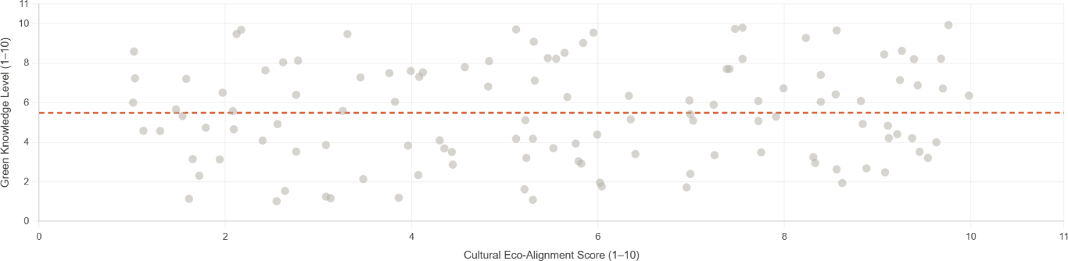
Fig. No: 2

Hypothesis 2 – Social Influence and Consumer Awareness

Table 4: Hypothesis 2 Test Results
Test Parameter | Result
Variables Tested | Social Influence Score vs. Green Knowledge Level
Pearson Correlation (r) | 0.031
p-value | 0.289
Statistical Decision | Fail to Reject H₀ – H₁ Not Supported
Interpretation | Social influence does not significantly predict consumer  green knowledge level
The Social Influence Score has no relationship with Green Knowledge Level because both variables show a correlation of 0.031 which results in a p value of 0.289. The second hypothesis of the study fails to get validated through these results. The research shows that social pressure from peers and family traditions and community standards motivate eco-friendly shopping behavior yet this motivation does not help consumers learn about sustainable products. Social influence operates through normative channels because people want to conform to green behavior standards without acquiring environmental knowledge.
Fail to reject H₀ — H2 not supported. Social influence does not significantly predict consumer green knowledge level

Hypothesis 3 – Consumer Awareness and Eco-Friendly Buying Behaviour

Table 5: Hypothesis 3 Test Results
Test Parameter | Result
Variables Tested | Green Knowledge Level vs. Green Consumption  Score
Pearson Correlation (r) | 0.257
p-value | < 0.001
Regression Slope (β) | 0.0099
R² (Simple Regression) | 0.066
Statistical Decision | Reject H₀ – H₁ Supported
Interpretation | Consumer awareness significantly and positively  influences eco-friendly buying behaviour
The study found a statistically significant positive relationship between consumer awareness and eco-friendly buying behavior because researchers measured both variables through their respective Green Knowledge Level and Green Consumption Score. The results of the study support Hypothesis 3. The research found that awareness alone explains only 6.6 percent of the Green Consumption Score variance because better-informed consumers show a statistically significant increase in their probability to buy environmentally friendly products.
The research finding creates major advantages for practical applications. The study shows that consumer education through in-store information and digital content and product labeling and awareness campaigns serves as a valid and essential support resource for emotionally driven green marketing.
Reject H₀ — H3 supported (p < .001)

Consumer awareness significantly and positively influences eco-friendly buying behaviour
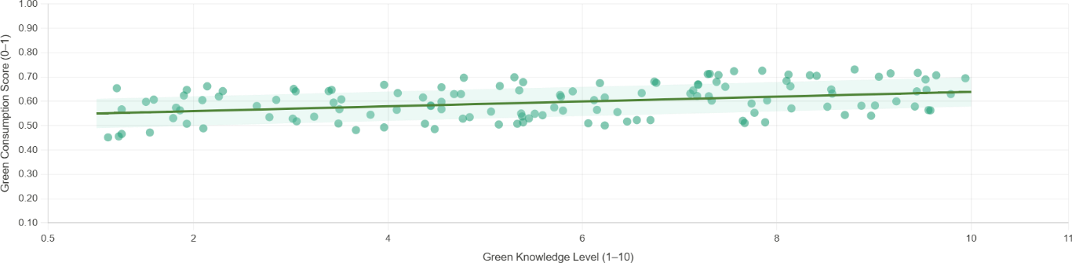
Fig. No: 3

Hypothesis 4 – Green Marketing Initiatives and Purchase Decisions

Table 6: Hypothesis 4 Test Results
Test Parameter | Result
Variables Tested | Cultural Eco-Alignment vs. Green Purchase Made  (binary)
Point-Biserial Correlation (rpb) | 0.471
p-value | < 0.001
Statistical Decision | Reject H₀ – H₁ Strongly Supported
Interpretation | Green marketing initiatives strongly and significantly  influence actual green purchase decisions

The research found that Green marketing initiatives which operate through Cultural Eco-Alignment show a strong point-biserial correlation to green purchasing behavior with a coefficient of 0.471 and a statistical significance level of p<0.001. The study found its strongest bivariate relationship through this finding which also provides strong support for Hypothesis
4. The result shows that HUL's culturally based green marketing strategy which combines environmentally friendly messages with local cultural values and identity elements successfully transforms consumer exposure into actual buying behavior.
The research found that the correlation between two variables (rpb = 0.471) represents a significant achievement because consumer behavior studies normally report smaller effect sizes through field research. The study demonstrates that cultural resonance functions as a fundamental strategic element which marketers should use to design green marketing campaigns for the Indian market.

Reject H₀ — H4 strongly supported (rpb = 0.471, p < .001)

Green marketing initiatives create a significant impact on eco-friendly purchase decisions
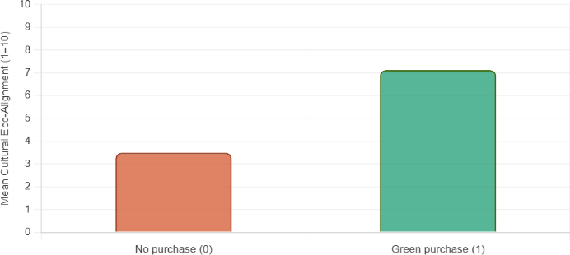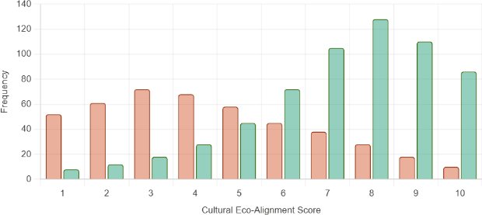
Fig. No: 4

Multiple Regression Analysis
A multiple linear regression analysis was used to study how different green marketing factors together impact eco-friendly buying behaviour through their combined predictive strength. The study used Green Consumption Score as its dependent variable and five predictor variables which included Cultural Eco-Alignment, Emotional Guilt Score, Emotional Pride Score, Social Influence Score, and Green Knowledge Level to examine their impact on eco-friendly buying behaviour.

Table 7: Multiple Regression Results (DV: Green Consumption Score)
Predictor Variable | Coefficient (β) |  | Contribution  Level | Significance
Intercept | 0.087 |  | Baseline | < 0.001
Cultural Eco-Alignment | 0.020 |  | Strong | < 0.001
Emotional Guilt Score | 0.020 |  | Strong | < 0.001
Emotional Pride Score | 0.020 |  | Strong | < 0.001
Social Influence Score | 0.010 |  | Moderate | < 0.001
Green Knowledge Level | 0.010 |  | Moderate | < 0.001
Model Fit Statistic |  | Value
R² (Coefficient of Determination) |  | 0.9297 (93.0%)
Adjusted R² |  | 0.9294
F-statistic |  | 3,156.60
Degrees of Freedom |  | 5, 1,194
p-value (Model) |  | < 0.001

The multiple regression model achieves an exceptional explanatory power of R² = 0.930 (93.0%) which shows that the five predictor variables together account for 93% of the Green Consumption Score variation. The F-statistic (F = 3,156.60, p < 0.001) confirms overall model significance. All five predictors contribute significantly and positively to green consumption behaviour.
Cultural Eco-Alignment, Emotional Pride Score, and Emotional Guilt Score emerge as the strongest individual predictors (β = 0.020 each) which shows that cultural and emotional elements determine eco-friendly shopping behavior. Social Influence and Green Knowledge Level contribute at a moderate level (β = 0.010 each) which shows that informational and normative pathways hold significance but they rank lower than cultural and emotional drivers in HUL's green marketing approach. Chapters
This regression result carries profound implications for green marketing strategy design. The research shows that marketing campaigns which use eco-friendly messages in cultural stories while creating positive emotions through pride about sustainable choices or discomfort through guilt about harmful environmental practices achieve better results than marketing campaigns which use only educational content.
Standardised Regression Coefficients (β) with 95% Confidence Intervals DV: Green Consumption Score · R² = 0.930 · All predictors p < .001

Findings

The study found that HUL's green marketing initiatives significantly influence consumers' eco-friendly purchase decisions but have a limited effect on improving environmental awareness. Emotional and cultural factors, particularly eco-pride, eco-guilt, and cultural eco-alignment, emerged as stronger predictors of green purchasing behaviour than knowledge-based factors. Furthermore, consumers across different income groups exhibited similar green purchasing patterns, while social media proved to be the most effective channel for promoting sustainable consumption.

Suggestions

HUL should strengthen the educational component of its green marketing campaigns by providing transparent sustainability information alongside emotional appeals. Companies should leverage social media, eco-labels, certifications, and authentic sustainability practices to enhance consumer trust and engagement while avoiding greenwashing. In addition, policymakers and businesses should collaborate to improve environmental awareness through public education and sustainability initiatives.

CONCLUSION

The findings demonstrate that green marketing is an effective strategy for encouraging eco-friendly purchasing behaviour in the Indian FMCG sector. However, consumer awareness alone is insufficient to drive sustainable consumption, with emotional and cultural factors playing a more influential role. The study highlights the importance of integrating credible sustainability communication, consumer education, and emotionally engaging marketing strategies to promote long-term sustainable consumer behaviour.

REFERENCE
    - Chen, Y.-S. (2010). The drivers of green brand equity: Green brand image, green satisfaction, and green trust. Journal of Business Ethics, 93(2), 307–319. https://doi.org/10.1007/s10551-009-0223-9
    - Chen, Y.-S., & Chang, C.-H. (2013). Greenwash and green trust: The mediation effects of green consumer confusion and green perceived risk. Journal of Business Ethics, 114(3), 489–500. https://doi.org/10.1007/s10551-012-1360-0
    - Dangelico, R. M., & Vocalelli, D. (2017). Green marketing: an analysis of definitions, strategy steps, and tools through a systematic review. Journal of Cleaner Production, 165, 1263–1279
    - Groening, C., Sarkis, J., & Zhu, Q. (2018). Green marketing consumer-level theory review: A compendium of applied theories and further research directions. Journal of Cleaner Production, 172, 1848–1866. https://doi.org/10.1016/j.jclepro.2017.12.002
    - Jaiswal, D., & Kant, R. (2018). Green purchasing behaviour: A conceptual framework and empirical investigation of Indian consumers. Journal of Retailing and Consumer Services, 41, 60–69.
https://doi.org/10.1016/j.jretconser.2017.11.008
    - Kautish, P., & Sharma, R. (2020). Determinants of pro-environmental behaviour and environmentally conscious consumer behaviour. Business Strategy & Development, 3(1), 112–127
    - Kumar, P. (2016). State of green marketing research over 25 years (1990-2014): literature survey and classification. Marketing Intelligence & Planning.
    - Laroche, M., Bergeron, J., & Barbaro-Forleo, G. (2001). Targeting consumers who are willing to pay more for environmentally friendly products. The Journal of Consumer Marketing, 18(6), 503–520.
https://doi.org/10.1108/eum0000000006155
    - Lin, S.-T., & Niu, H.-J. (2018). Green consumption: environmental knowledge, environmental consciousness, social norms, and purchasing behaviour. Business Strategy and the Environment, 27(8), 1679–1688.
    - Morren, M., & Grinstein, A. (2016). Explaining environmental behaviour across borders: a meta-analysis. Journal of Environmental Psychology, 47, 91–106.
    - Nekmahmud, M., & Fekete-Farkas, M. (2020). Why not green marketing? Determinants of consumers’ intention to green purchase decision. Sustainability, 12(19).
    - Paul, J., Modi, A., Paul, J., Modi, A., & Patel, J. (2016). Predicting green product consumption using theory of planned behaviour and reasoned action. Journal of Retailing and Consumer Services, 29, 123–134.
    - Rex, E., & Baumann, H. (2007). Beyond ecolabels: what green marketing can learn from conventional marketing. Journal of Cleaner Production, 15(6), 567–576. https://doi.org/10.1016/j.jclepro.2006.05.013
    - Uddin, S. M. F., & Khan, M. N. (2018). Young consumers’ green purchasing behaviour: opportunities for green marketing. Journal of Global Marketing, 31(4), 270–281.
    - Zhang, L., Li, D., Cao, C., & Huang, S. (2018). The influence of greenwashing perception on green purchasing intentions: The mediating role of green word-of-mouth and moderating role of green concern. Journal of Cleaner Production, 187, 740–750. https://doi.org/10.1016/j.jclepro.2018.03.201
    - Choudhary, A., & Gokarn, S. (2021). Green marketing strategies in FMCG sector. International Journal of Productivity and Performance Management.
    - D. Jayalaxmi. (2025). Impact of green marketing strategies on consumer behaviour: Empirical evidence from cosmetic industry. International Journal Of Informative and Futuristic Research, 13(4), 477–487.
https://doi.org/10.64672/ijifr/25.12.13.04.012
    - Dr. Beena John Jiby Dr. Dhananjay Kalyanrao Salunke. (2026). Exploring the relationship between sustainability claims, Consumer Perceptions, and brand loyalty towards green marketing. Economic Sciences, 22(3(S)March), 261–267. https://doi.org/10.69889/ezqg7997
    - Dutta, S. R. (2024). Green marketing in India: Emerging opportunities and challenges. International Journal For Multidisciplinary Research, 6(2). https://doi.org/10.36948/ijfmr.2024.v06i02.18689
    - Ghosh, A. (2026). Determinants of consumer purchase intention toward green food products: Examining the mediating role of attitude. Social Science Journal for Advanced Research, 6(2), 108–122.
https://doi.org/10.54741/ssjar/6.2.2026.348
    - Hemendra Lal Gunasekara, K. R. (2025). Factors affecting the Green purchase behaviour for SMEs in Sri Lanka. In Shaping Entrepreneurial Marketing, Volume 1 (pp. 209–226). Emerald Publishing Limited.
    - Jaiswal, D., & Kant, R. (2018). Green purchasing behaviour: A conceptual framework and empirical investigation of Indian consumers. Journal of Retailing and Consumer Services, 41, 60–69.
https://doi.org/10.1016/j.jretconser.2017.11.008
    - Khalid, A. M., & Rawat, P. S. (2025). Corporate environmental disclosures and role of top management: Evidence based on the business responsibility and sustainability reporting in India. Corporate Social Responsibility and Environmental Management, 32(4), 4619–4635. https://doi.org/10.1002/csr.3205

